Manual Test Plan

# Project Configurations:

The following software should be used when testing:

IntelliJ or Eclipse

Java SDK v11

JUnit 4

All platforms

# Testing Environment:

Ensure that all source code and image files are present for the piece images and Chess logic.

Run the Display.java class to show the Chess GUI display.

For a standard game, navigate to Display.java line 33 and set boardScr = new BoardScreen(false).

For a custom game, change Display.java line 33 to boardScr = new BoardScreen(true).

Close the window of the GUI before changing these settings and rerun the Display.java class to display the changed settings.

# Standard Game:

Ensure that in Display.java line 33 that boardScr = new BoardScreen(false) is entered to create the chess GUI for a standard board. When the Display class is run, the window below should pop up:

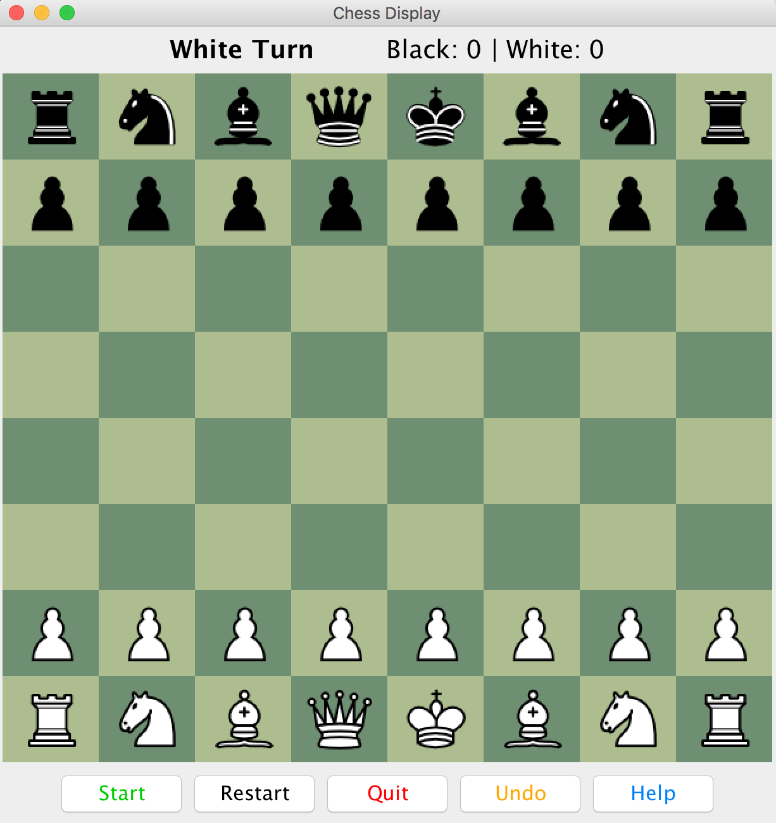

* Make sure all the colors of the pieces are correct with the black side on the top, and white side at the bottom.
* All the images for the pieces appear as they should according the standard configuration of a chess board
* Ensure the tiles are colored alternating with dark green and light green

# Resizing the Window

Drag the window of the Chess game across the screen and ensure the whole frame updates

Resize the window to full screen and observe that the board scales with the window:

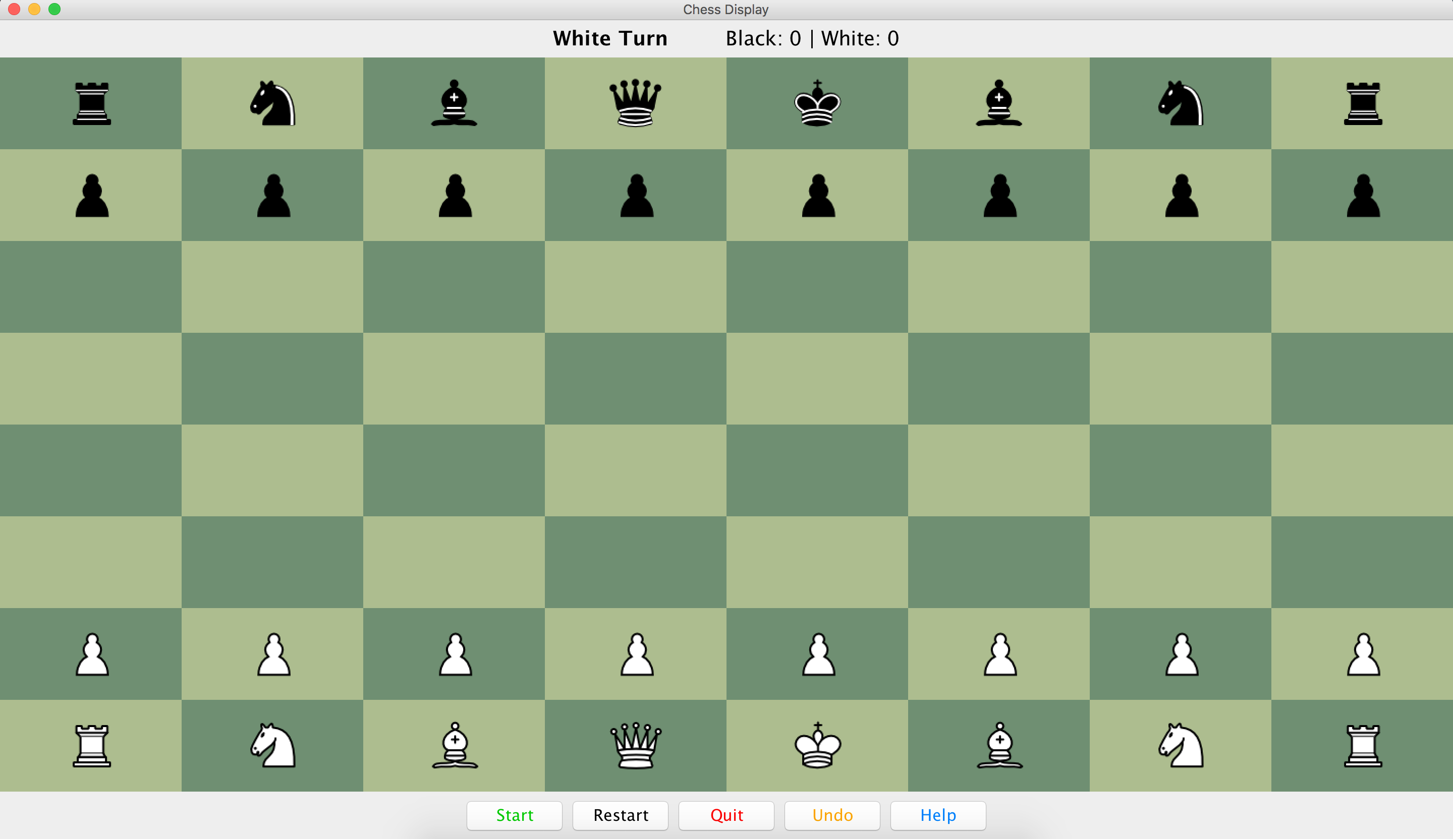

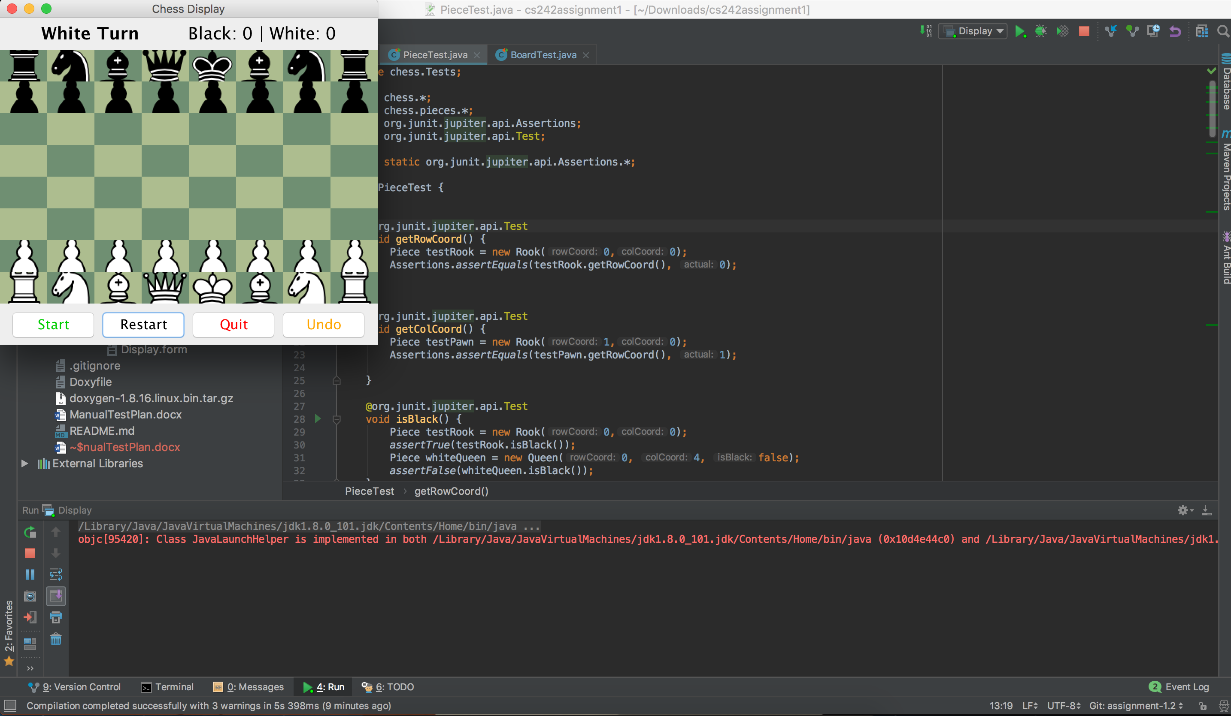Resize the window to get smaller until the pieces take up the entire square and ensure that the board scaled accordingly.

# Interaction:

From the initial window screen, click on the white pawn in the bottom row in the fifth column. You should see the square highlighted in yellow

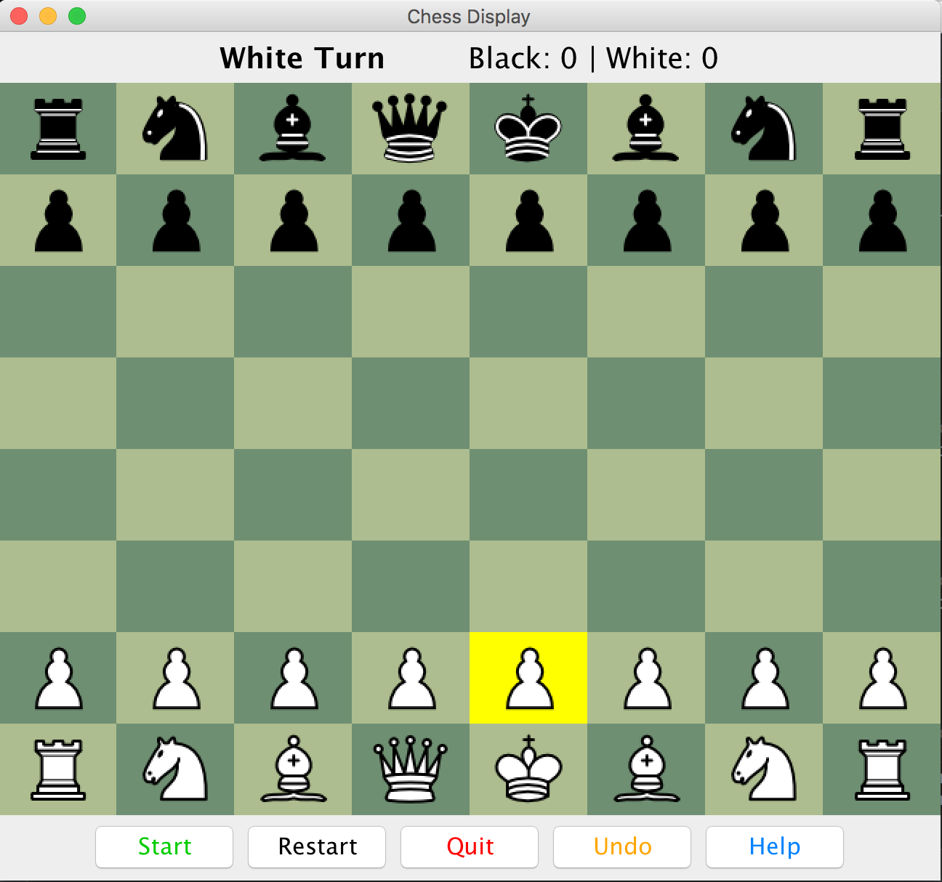

When clicking on a square with no Piece, a dialog should appear stating the square’s coordinates as well as saying that there is no piece present on that square. Ensure that all empty squares say there is no piece on that spot:

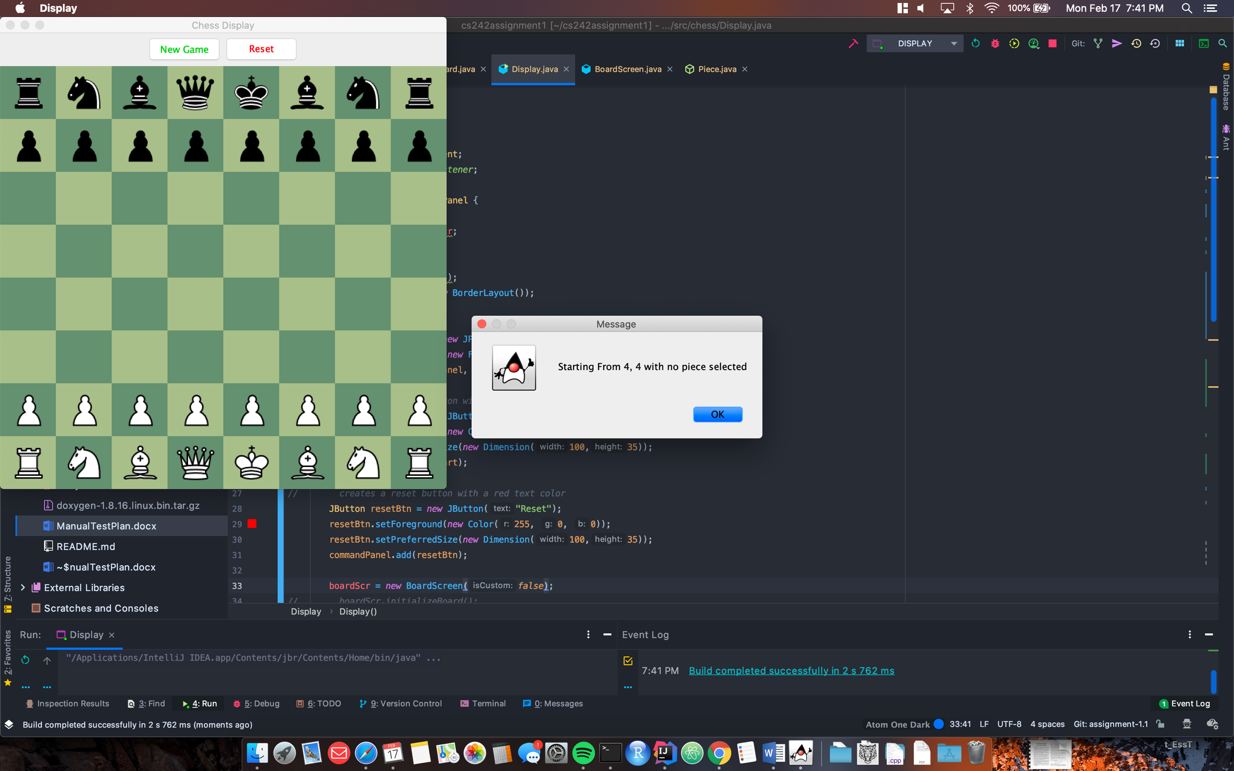

Movement: After successfully moving a piece verify that the piece actually moves

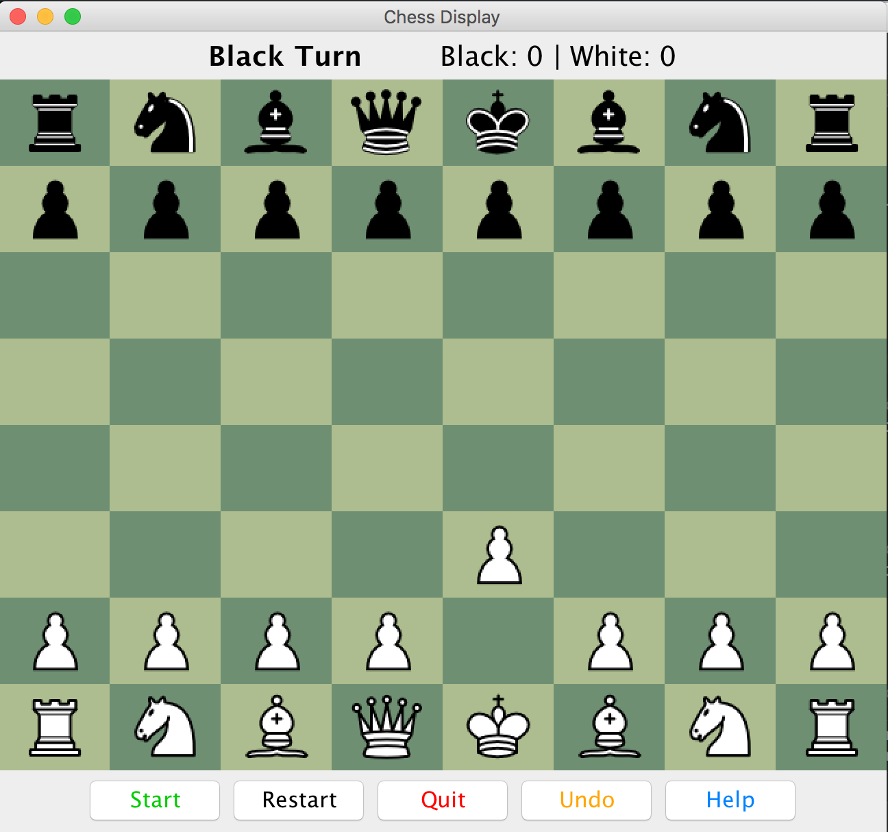

# Errors:

Clicking on a non-piece to start:

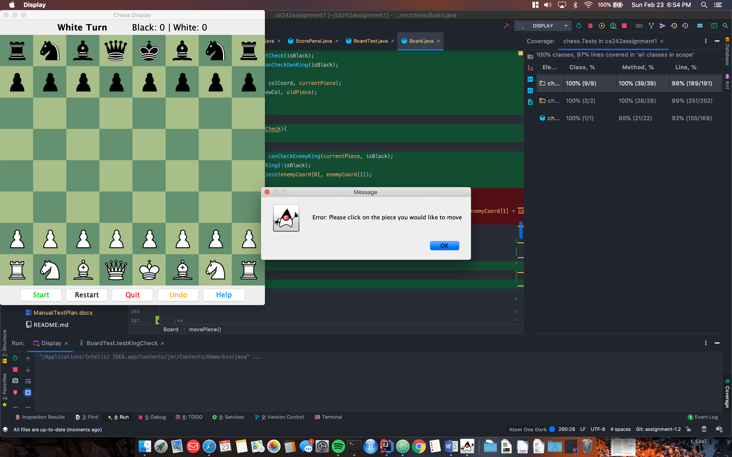

Clicking on the same square twice:

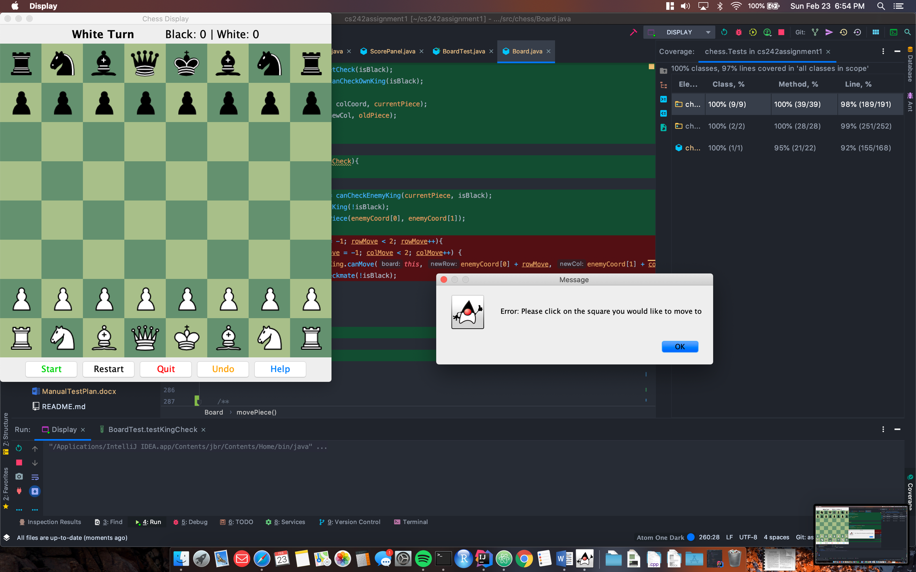

Trying to make a move that is not possible by Chess rules:

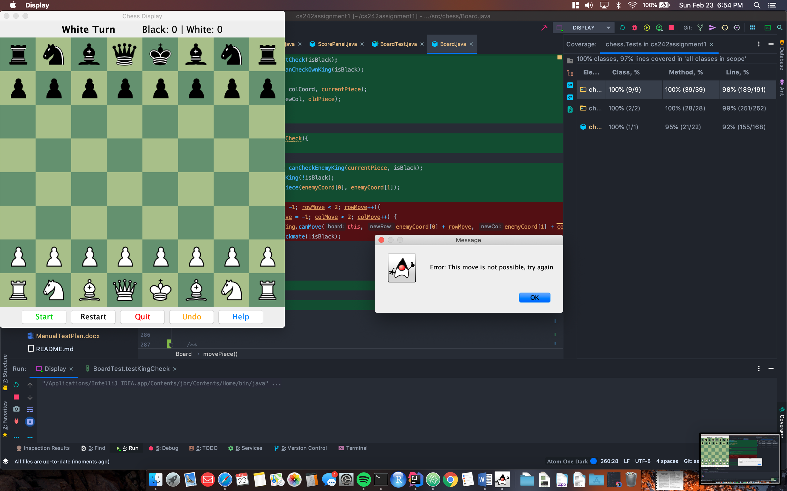

# Command Panel:

Observe that the buttons on the top of the window say New Game in green and Reset in red. The buttons should stay the same size as the window is resized.

When the New Game button is clicked, a dialog should appear saying “Pressed Start Game”

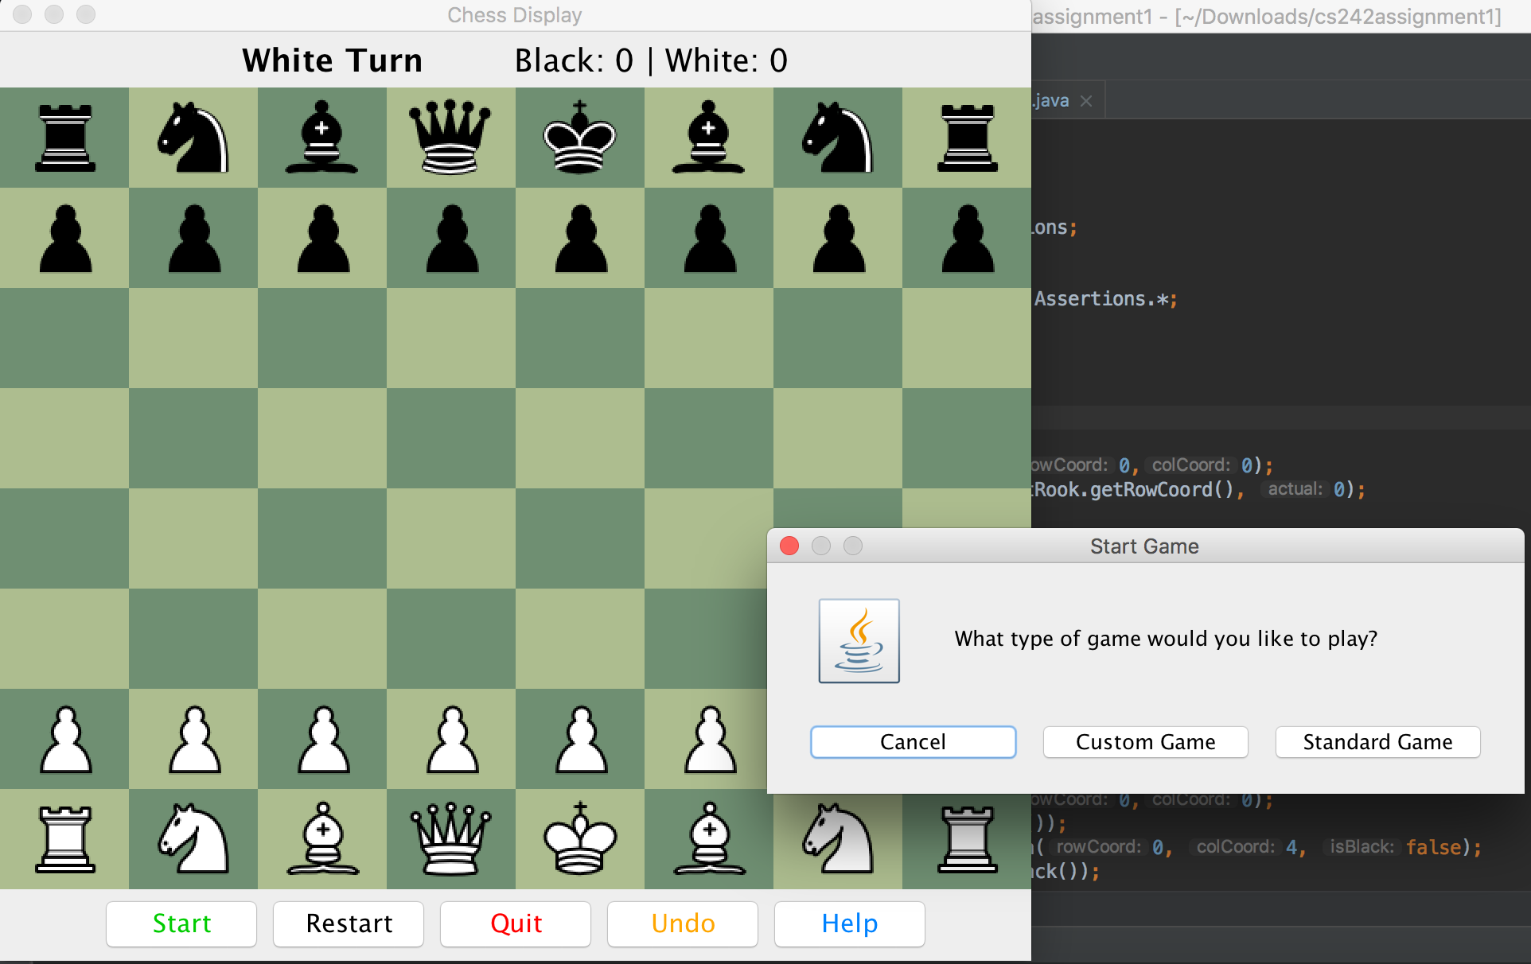

Now press the restart button:

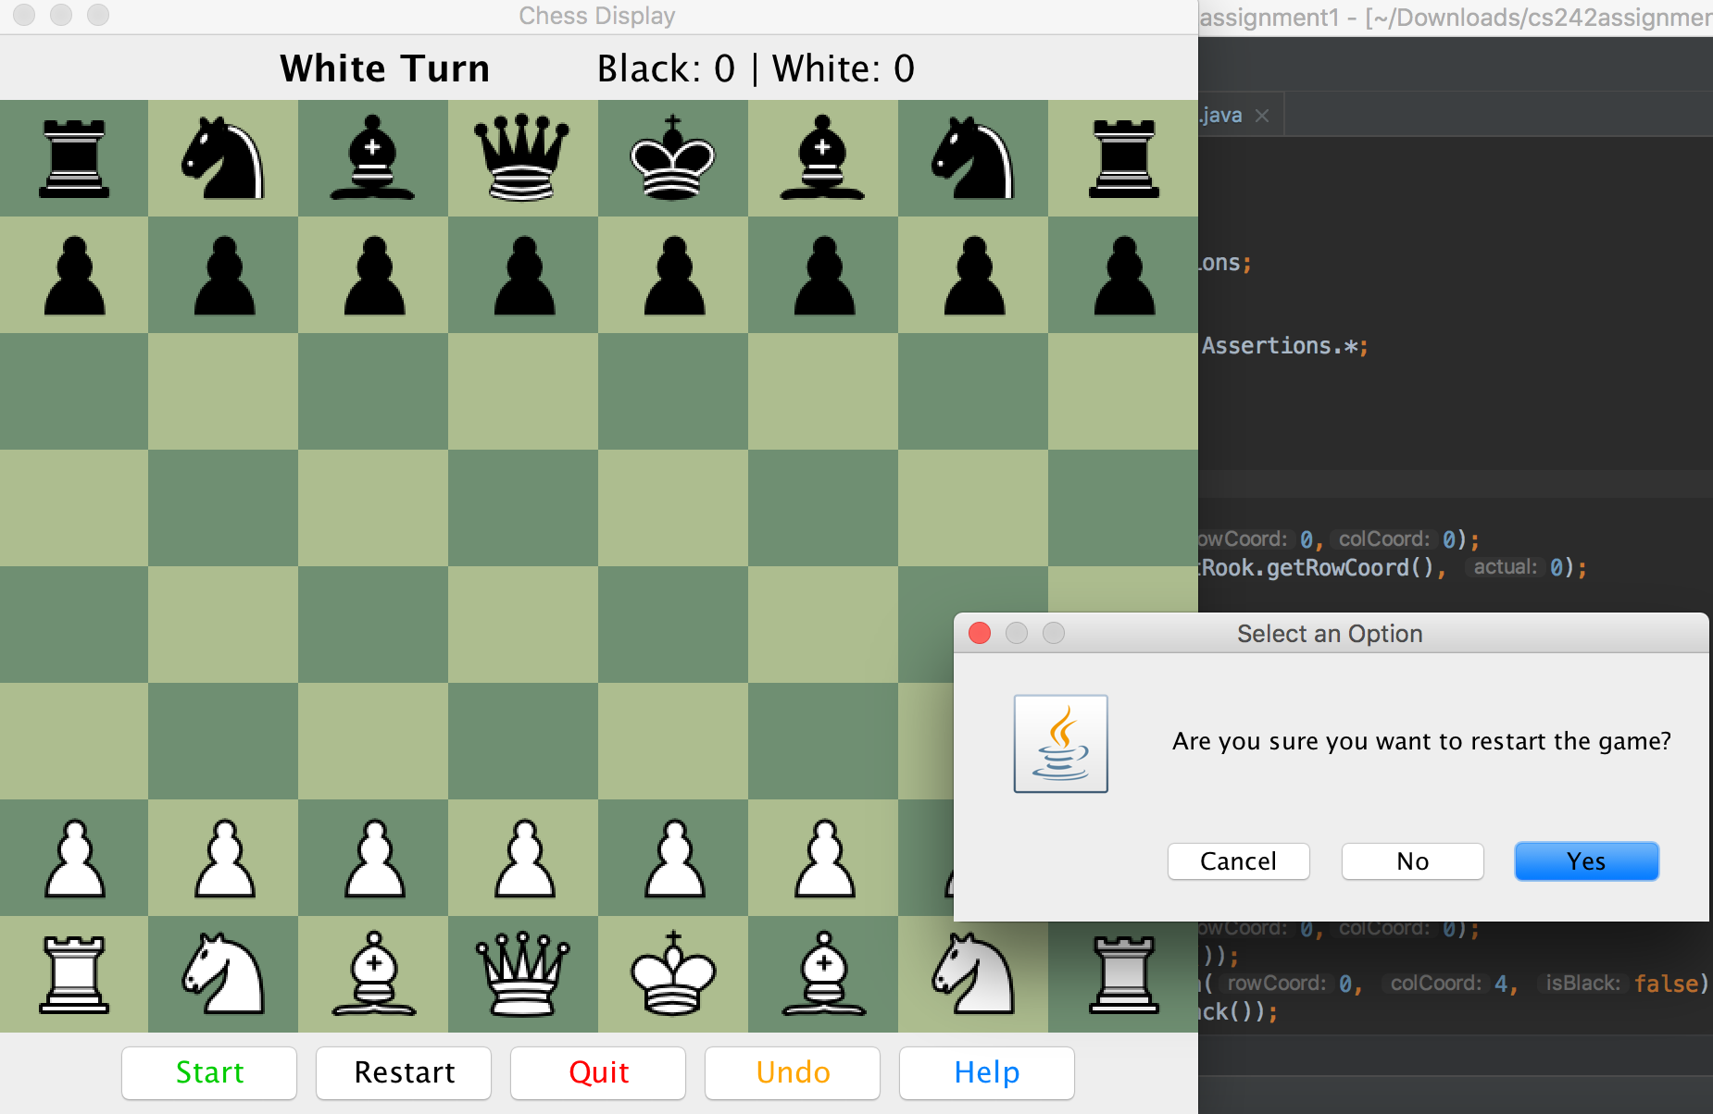

Quit:

Click on which player wants to quit:

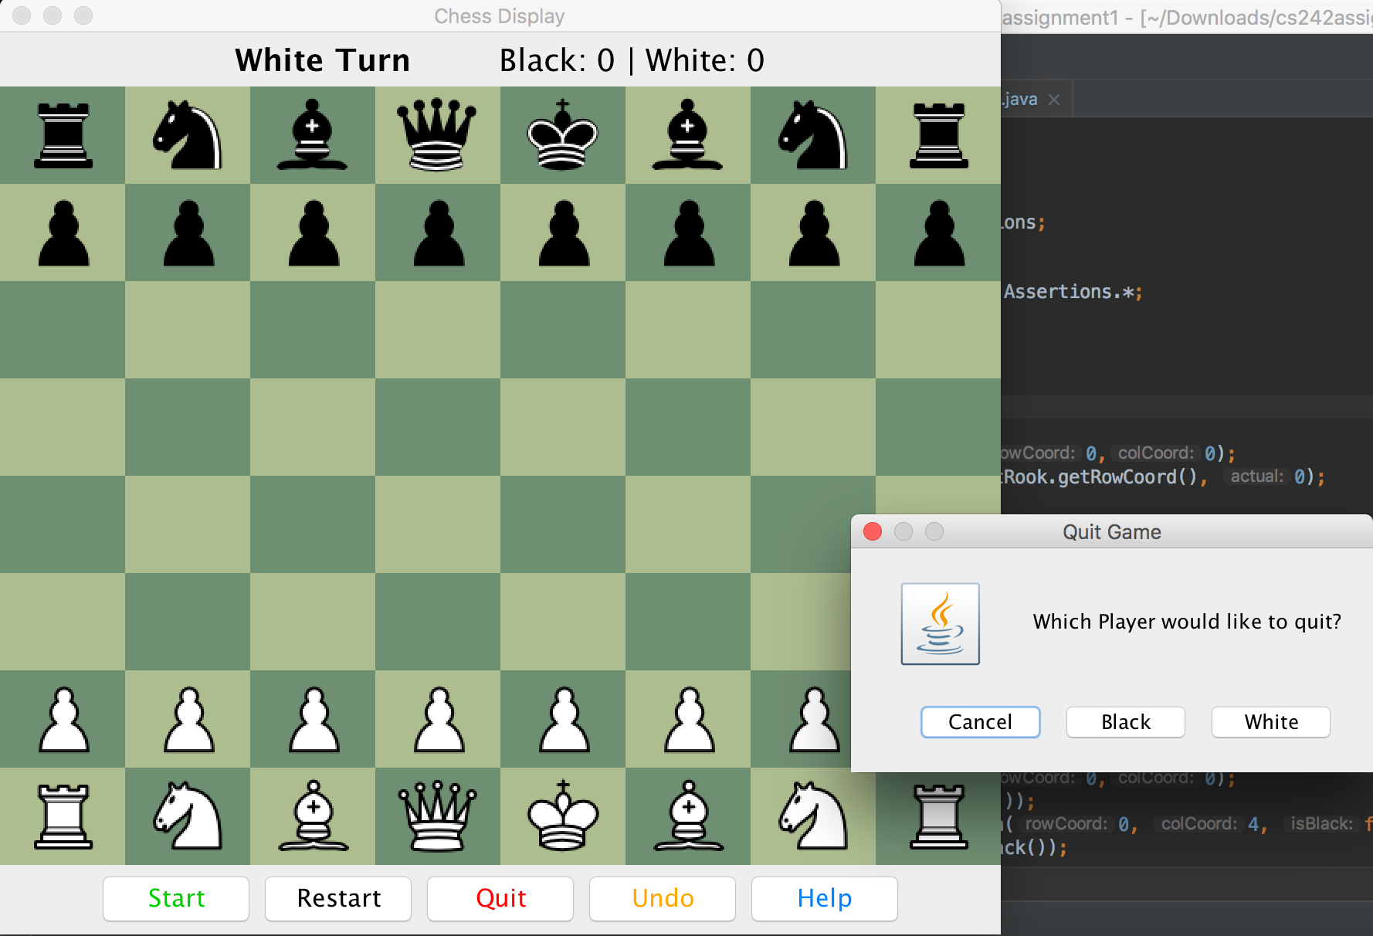

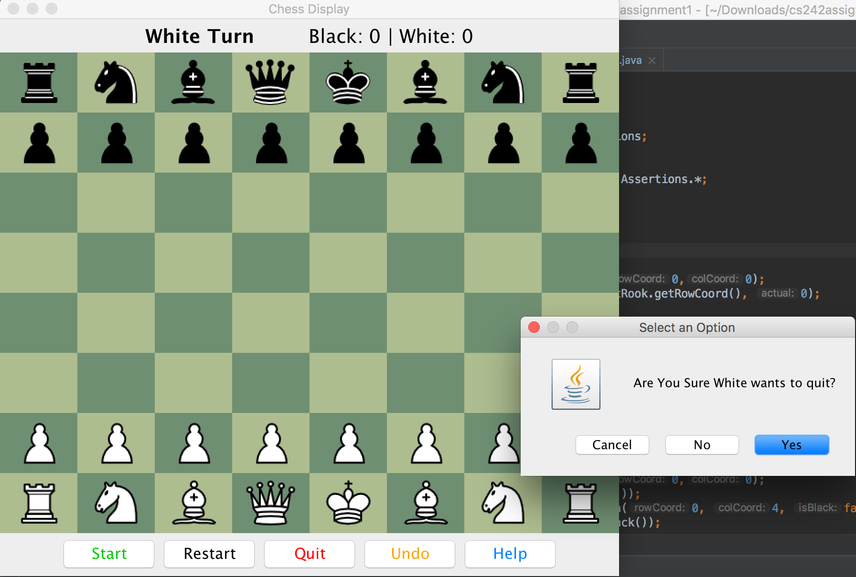

Undo:

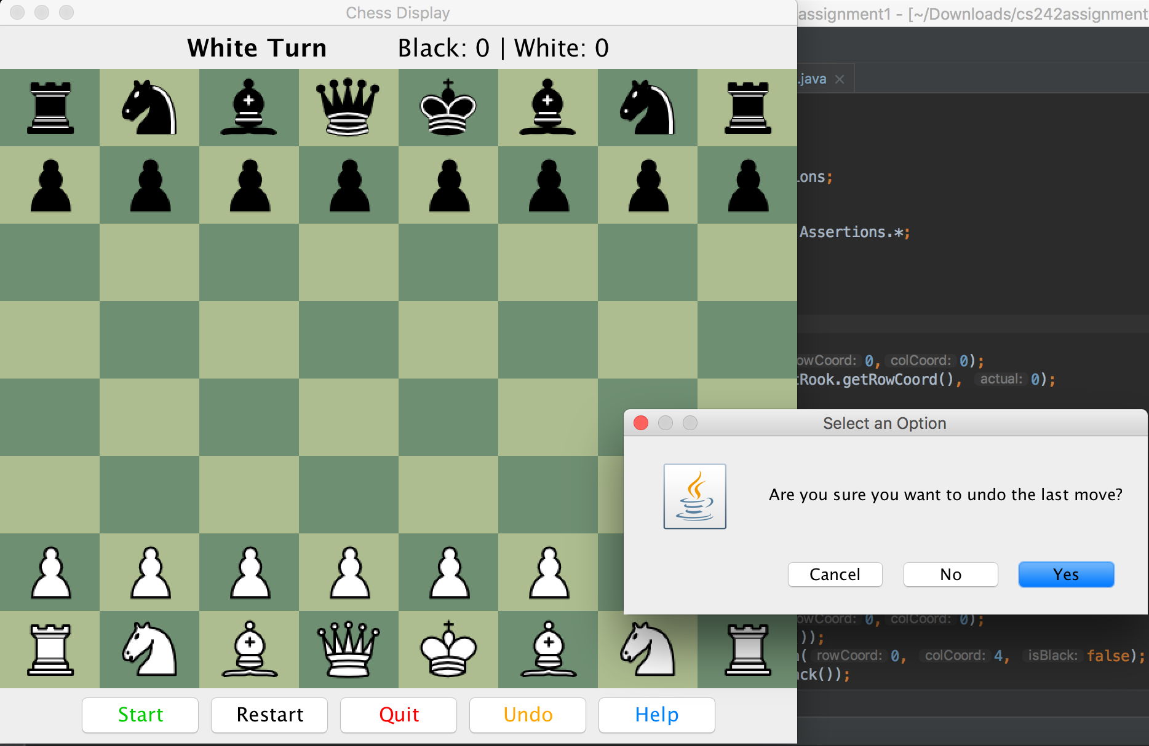

Help:

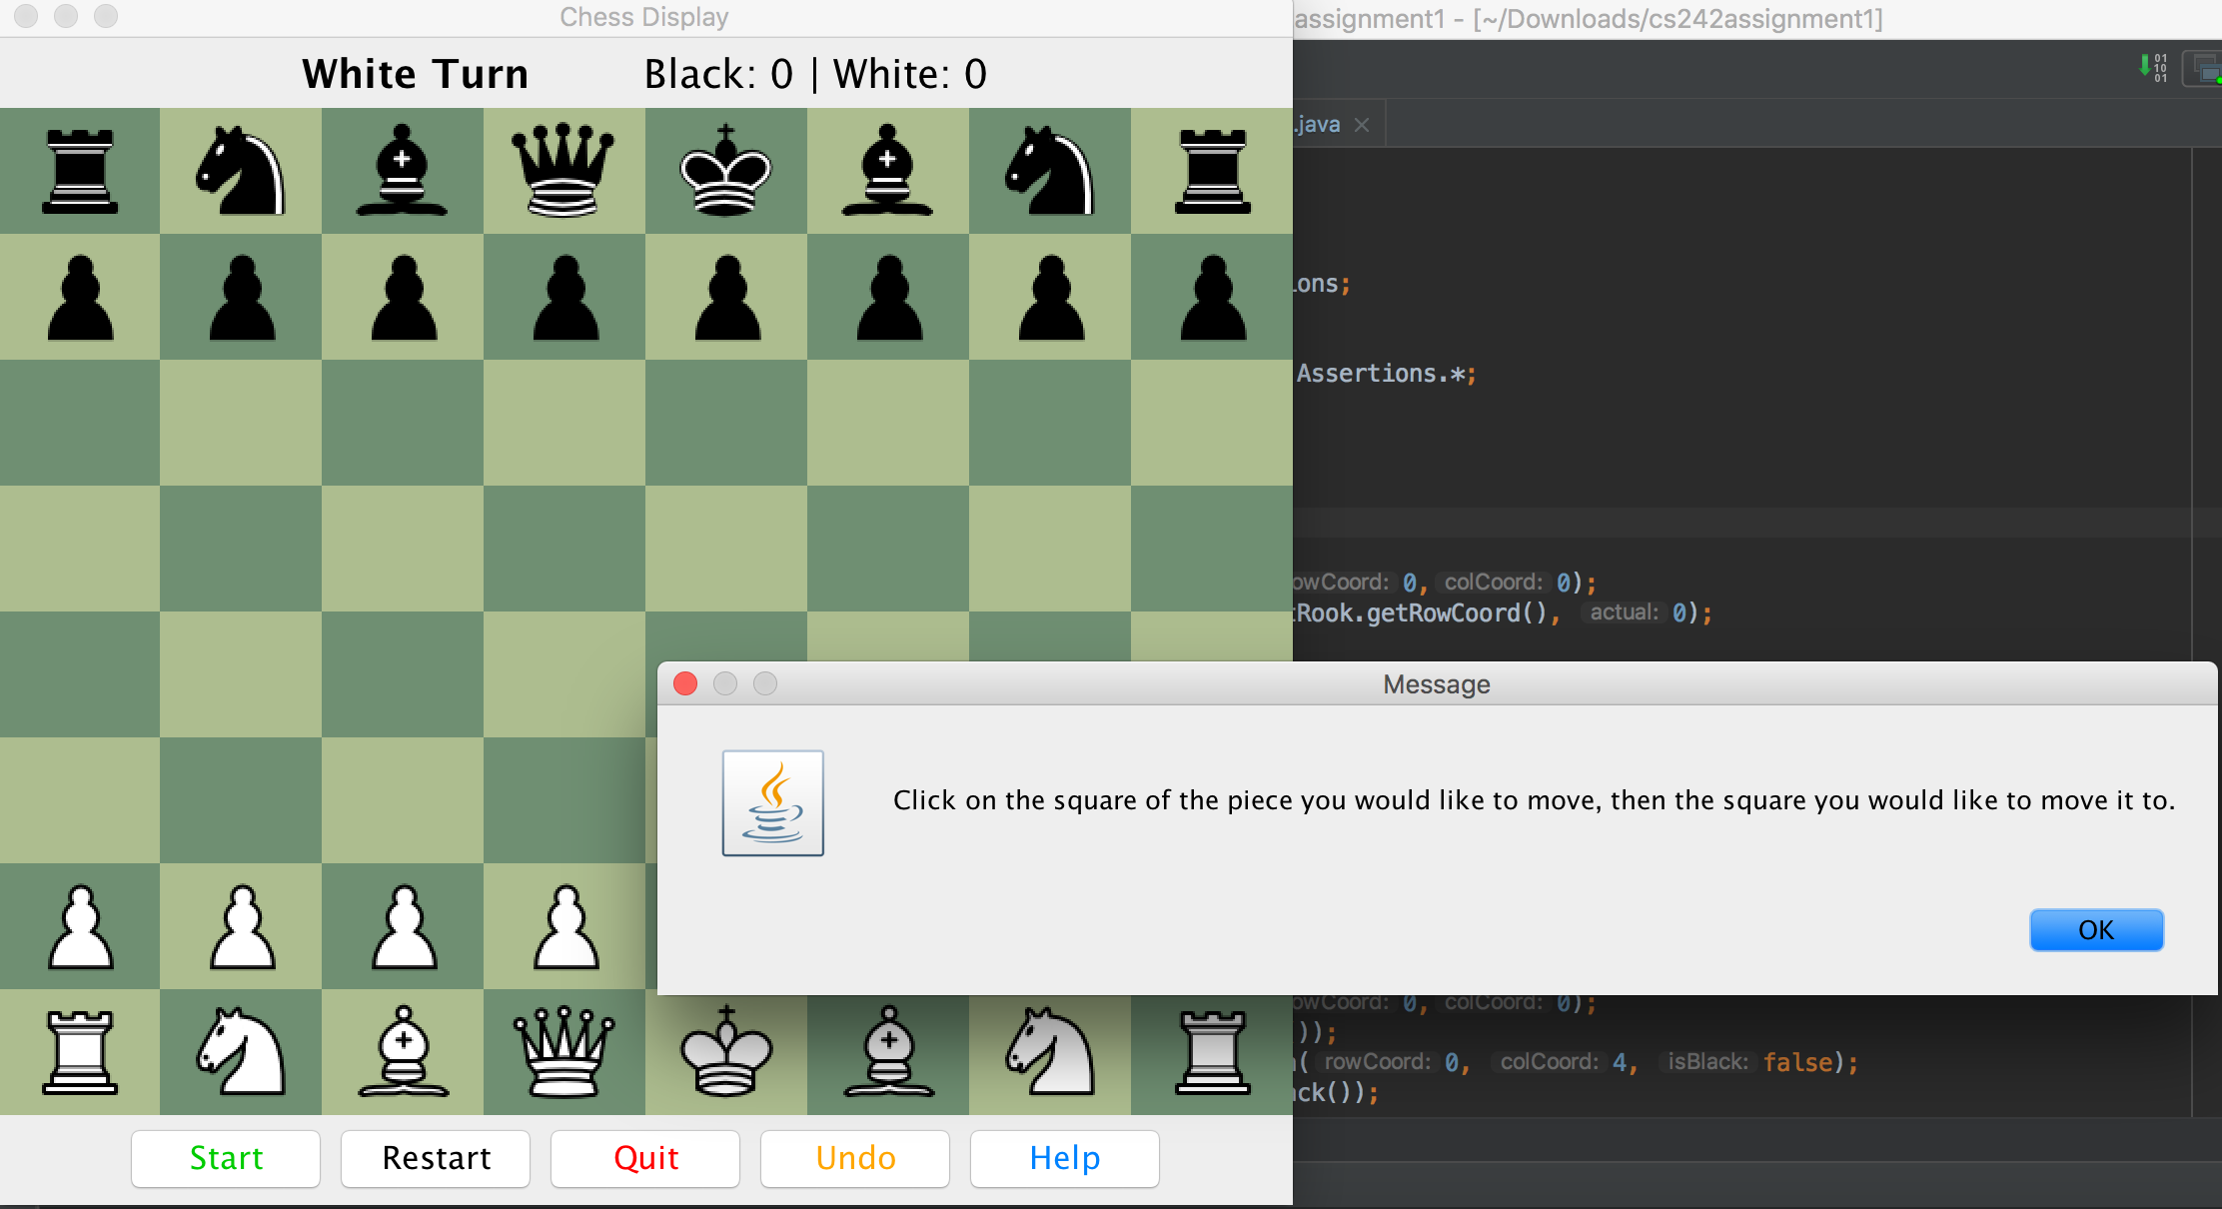

# Custom Board GUI

To setup the Custom board, go to the Display.java class. On line 33, ensure that it says:

boardScr = *new* BoardScreen(*true*);

This will create a custom board and when the Display is run again, the following window should pop up. It will display the pieces but the two end pawn pieces for each player should be replaced with the Tiger and Orbit custom pieces. Ensure that the colors and piece image are correct, as well as the background color for the tiles.

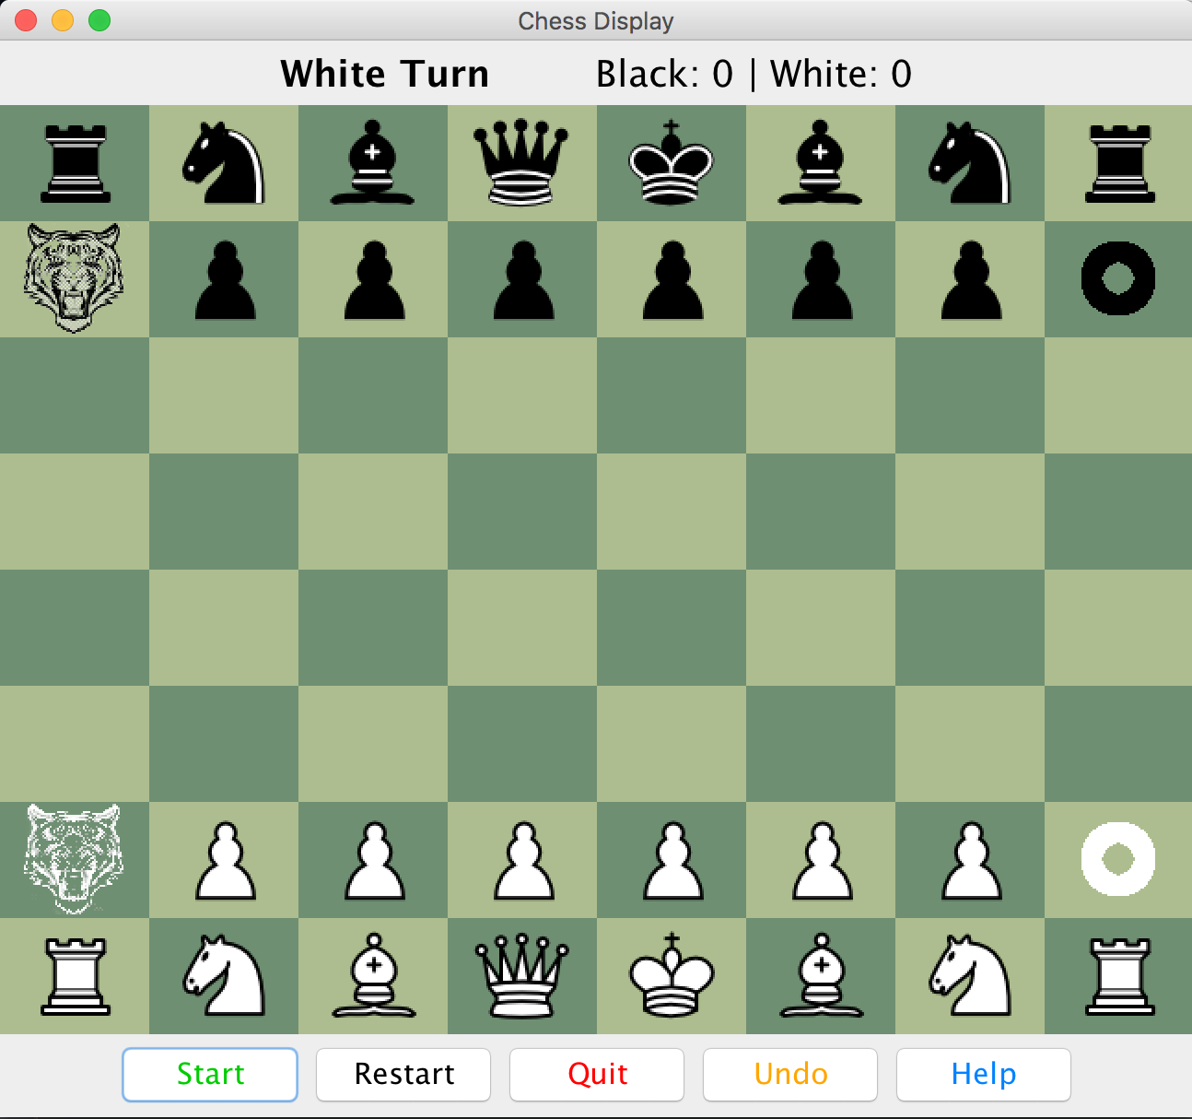

# Interaction:

Repeat the same interaction steps as stated above for the standard game. In addition to the standard pieces, the custom pieces should also be shown and clicking on the Black Tiger and the White Orbit should behave as described by their rules.